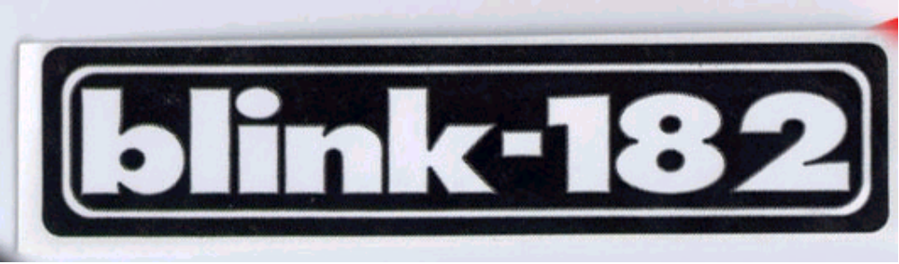
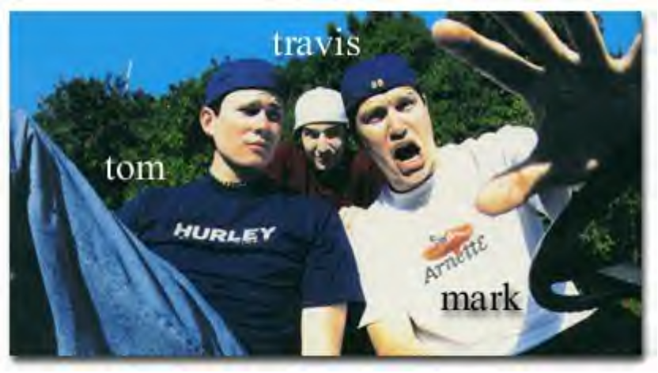
Blink 182 is a three piece punk band from San Diego, California. Blink 182 is made up of guitarist Tom DeLonge, bassist Mark Hoppus, and drummer Travis Barker. They first started out with the name Blink but when they were sued by a British band with the same name, they added three random numbers which happened to be 182. Blink 182 started in 1992 in Tom's garage writing songs. Wait...let's start from the beginning.....
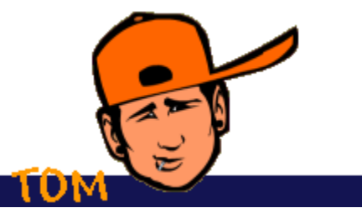
Thomas Matthew DeLonge was born on December 13, 1975. Tom would be the oldest of two more children, Kari and Shawn. Tom's family was quietly religious. He attended church on Sundays but wasn't held with strict religious rules. Tom was always a trouble maker. The first instrument Tom played was the trumpet which his mother and father bought him. His parents always joked that when he got good enough, he could wake them up in the morning by playing a song. Not being able to wait of course, Tom one morning stood outside his parents' door and played (or at least tryed to play) a song. Tom's Dad was furious but his Mom thought it was cute.
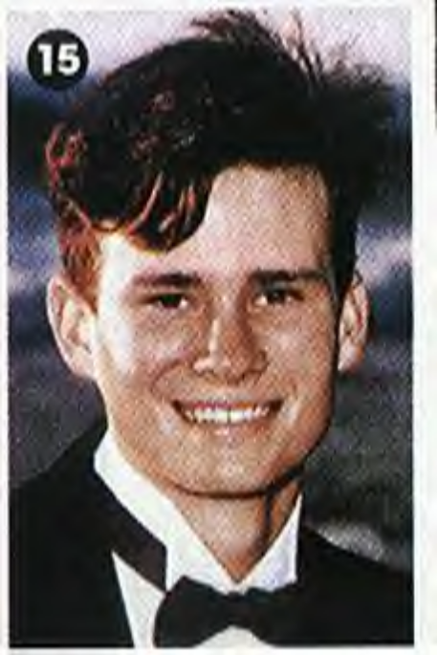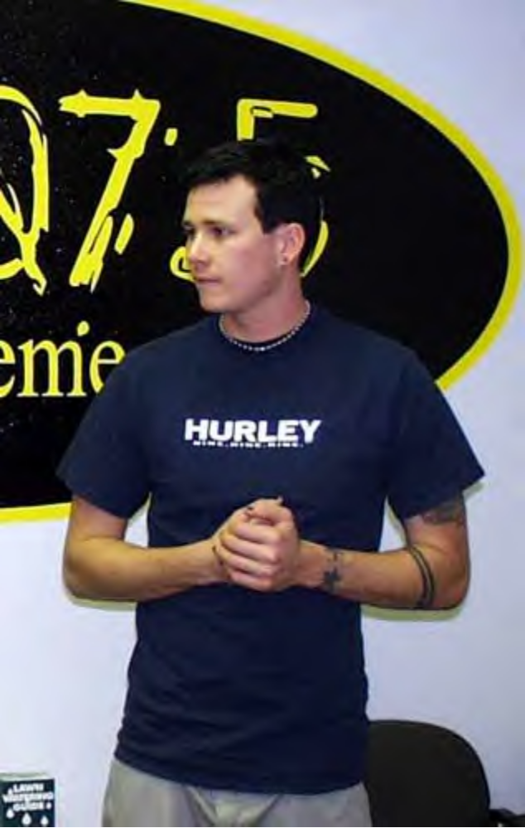
Growing up in Poway, California was fun for Tom. Skateboarding and causing havoc in this small town was Tom's specialty. Skating through malls and knocking as many shelves down as possible was something Tom did often with his punker friends. In high school, Tom was popular..yet different. He was voted Homecoming King to make the teachers mad! He got kicked out of high school once because he was drinking beer at a basketball game after school and his teachers saw him before the age of 15! He worked at local restaurants and was a concrete pipe truck driver in high school. Tom realized his love for the guitar when he went to camp and a fellow bunkmate had a guitar. Tom couldn't set it down the entire time!

Markus Allen Hoppus was born on March 15, 1972. His parents divorced when Mark was 14 years old. Mark and his sister (Anne) were split when Mark's mother moved to California and Mark stayed with his father, Tex, who was a high tech weapons engineer for the US Navy. Because of Tex's job, Mark spent his childhood moving around not making friends easily. Mark often missed his other family members and he did so bad that he eventually moved in with his mother in California.
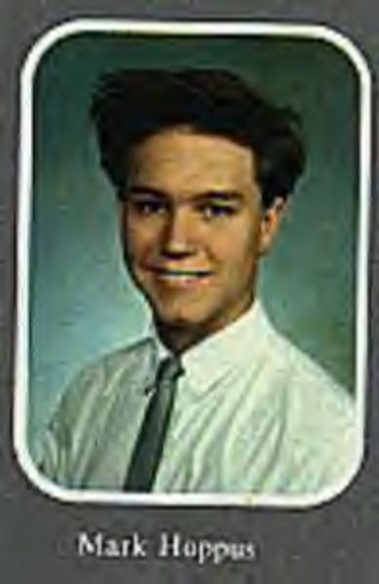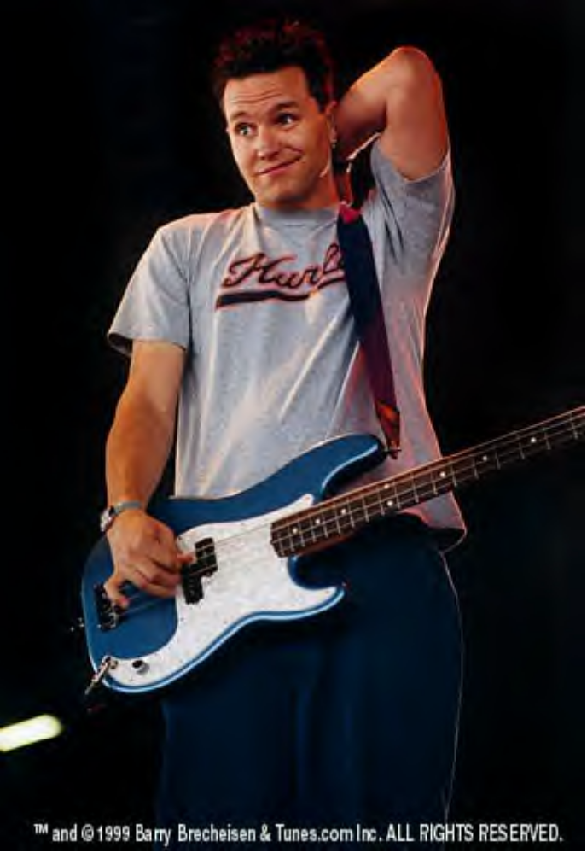
Mark wasn't exactly an honor student. Getting bad grades and not having very many friends, Mark roughed his way through high school. As a present for helping him paint a fence, Tex bought Mark a bass guitar and so started Mark's love for punk music. Mark was the type of kid who wore mascara to school and nobody liked.....that is until Anne (his sister) introduced him to his soon-to-be bandmate, Tom. In order to impress Tom, Mark climbed a telephone pole and jumped off, cracking his heels and in turn having to have crutches for a month! Mark wanted to become a high school English teacher and enrolled in a local California college but dropped out when he ran out of money and wasn't keeping his grades up. I don't think he regretted his choice!

Tom's friend's girlfriend (Anne) who is also Mark's sister introduced Mark and Tom when Mark moved into town. They instantly clicked with the same love for girls, music, life, and chronic diarrhea. Becoming friends, they decided to start a garage punk band, but first....they needed a drummer. Entrance Scott Raynor...the youngest member of the band. At the age of 15, Scott was into heavy metal music like Metallica not punk like The Descendants like Mark and Tom. Alas, he joined the band anyway. In 1993, Blink 182 was complete.

Blink's first name was "El Cuatro and the Cajones" and they would play at weddings, birthdays, and even at their high school's lunch hour! Finally going from the name Blink to Blink 182, the guys released their first cassette that they sold out the back of a van. "Flyswatter" sold only about 200 copies but it brought them fans in the northern California area. Blink 182 now admits that they hate this first release.

Finally, landing a record label (Grilled Cheese, a division of Cargo Music), the three boys released their first album, Cheshire Cat in 1994. This group of three guys singing about the loss of girlfriends, the hardships of high school, and whether or not their breath stunk took the fans by storm. But it wasn't until 1997, when the band released "Dude Ranch" that people would start to realize that Blink 182 was here to stay. It was this album that brought Blink their fame with singles like "Dammit" and "Josie" which were played on radio and Mtv.

Everything was looking peachy keen for the guys, when suddenly Scott decided he wanted to quit, for personal reasons. He claimed that he left for another band and to go to college. This hurt the guys and they don't often talk about it. This is when Tom and Mark decided to recruit a new drummer. Travis Barker was this new drummer who had come straight from the nine-piece band The Aquabats. Travis was the silent type right from the start but he brought the awesome drumming that gives the band's songs its umph.

Travis Landon Barker was born on November 14, 1975 in Fontana, California. Travis began playing the drums at the age of 4 and had the same drum set until he was 15 years old. His mother died the day before he started high school but her last words to him were to keep playing the drums because that's what he loved to do. Travis then joined the band Feeble but quit to join the Aquabats where he got the stage name "Travis Baron Von Tito." He left the Aquabats and joined Blink 182 in 1998.
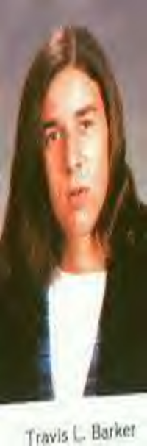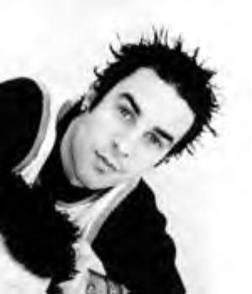
With a new drummer and the band put back together, Blink began working on a new album on MCA Records. On July 21, 1999, Blink 182 released their biggest album to date. "Enema of the State" was a mix of hilarious break-up songs with a punk/pop sound that caught the attention of thousands of viewers through the power of Mtv and radio. With hit singles like "What's My Age Again," "All the Small Things," and "Adam's Song," Blink took the world by storm and began touring.

After a successful tour, the guys decided to release a live album. "The Mark, Tom, and Travis Show" was an action-packed album filled with live songs and live jokes by Tom and Mark on stage. This album was released in November of 2000. After a long time touring, Blink was ready to release a new album filled with more punk songs like "Dude Ranch" rather than "Enema of the State." "Take Off Your Pants and Jacket" was more of an old-school album once again with songs of girlfriends, first dates, and break-ups, all in all the life of a high schooler.
Favorites and Such
TOM:
Movie: Anything with Mel Gibson naked
Bands: Jimmy Eat World, Propaghandi, Beastie Boys, Screeching
Weasle, The Queers, Bad Religion
Pet: A german shepard named Grey
Residence: Encinitas, California
Food: Burritos
Boxers or Briefs: Boxers
Clothing Brands: Attucus and Hurley
Shoes: Converse Allstars
Instrument: Guitar
Astrological Sign: Sagitarius
MARK:
Movie:
Band: Bad Religion
Pet: A beagle named Ahi
Residence:
Food: Burritos
Boxers or Briefs: Both
Clothing Brands:
Instrument: Bass Guitar
Astrological Sign: Pisces
TRAVIS:
Movie:
Band:
Residence:
Food:
Boxers or Briefs: Boxers
Clothing Brands: Famous Stars and Straps
Instrument: Drums
Astrological Sign: Scorpio
Various Facts:
TOM:
- Tom strongly believes in UFO's and aliens
- Tom is the one who came up with the album title "Enema of the State"
MARK:
- Mark's favorite song to sing is "Don't Leave Me"
- Mark believes his job is to act like the village idiot
TRAVIS:
- Travis owns a store called Famous Stars and Straps which sells
clothes, pictures of Marilyn Monroe, and candles, etc.
- Travis teaches kids how to play the drums on his down-time

